UNIVERSITI TEKNOLOGI MALAYSIA
Faculty of Computing
SEMESTER 1 SESI 2024 / 2025
LAB ACTIVITY
SECP 2523 DATABASE (WBL)

AHLI KUMPULAN :

1. CHEW CHIU XIAN A23CS0061
2.
3.


LAB 1 – Creating a Database

CREATING THE TENNIS LOGOS DATABASE

Tennis Logos (TL) supplies customized tennis clothing and accessories for clubs and tournaments. The company purchases these items from suppliers at wholesale prices and adds the customer’s logo. The final item price is determined by marking up the wholesale price and adding a fee that is based on the complexity of the logo.

Tennis Logos also does graphic design work for customers. Currently, the information about the items and the suppliers is stored in two Excel workbooks. Each item is assigned to a single supplier, but each supplier may be assigned many items.

You are to create a database that will store the item and supplier information. You already have determined that you need two tables, a Supplier table and an Item table, in which to store the information.

Instructions: Perform the following tasks.

- Use the Blank desktop database option to create a new database in which to store all objects related to the items for sale. Call the database – TL_Sport Database.
Answer:

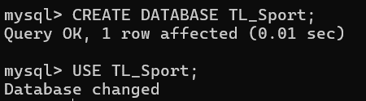

- Create the Supplier table using the structure shown in Figure 1. Use the name Supplier for the table.
Answer:

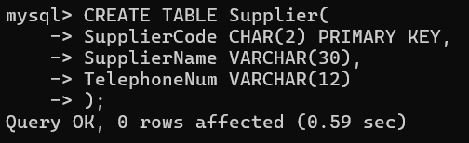

- Add the data shown in Figure 2 to the Supplier table.
Answer:

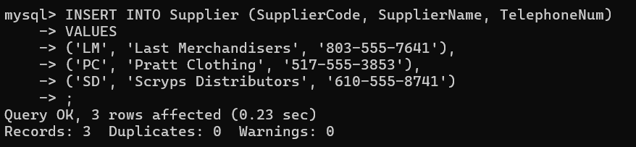

- Print the Supplier table.
Answer:

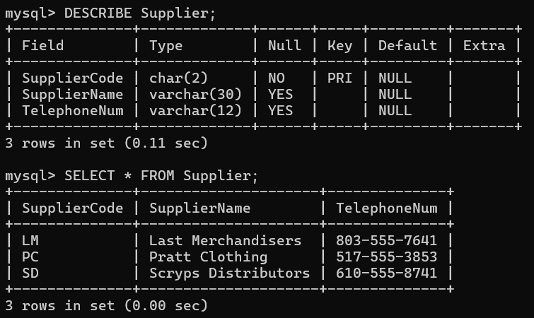

- Create the Item table using the structure shown in Figure 3. Use the name Item for the table.
Answer:

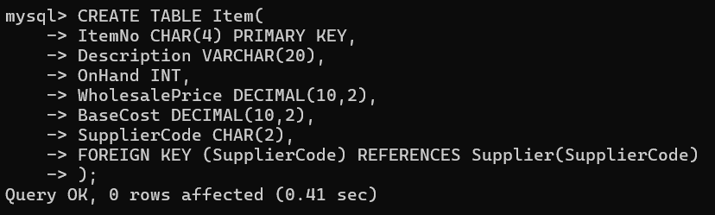

- Add the data shown in Figure 4 to the Item table.
Answer:

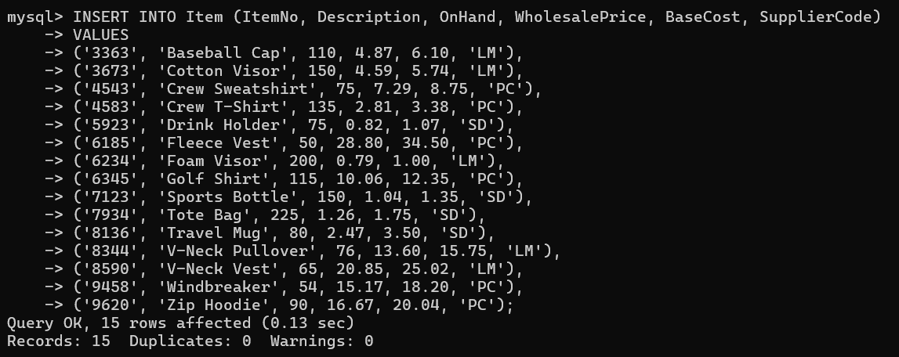

- Print the Item table.
Answer:

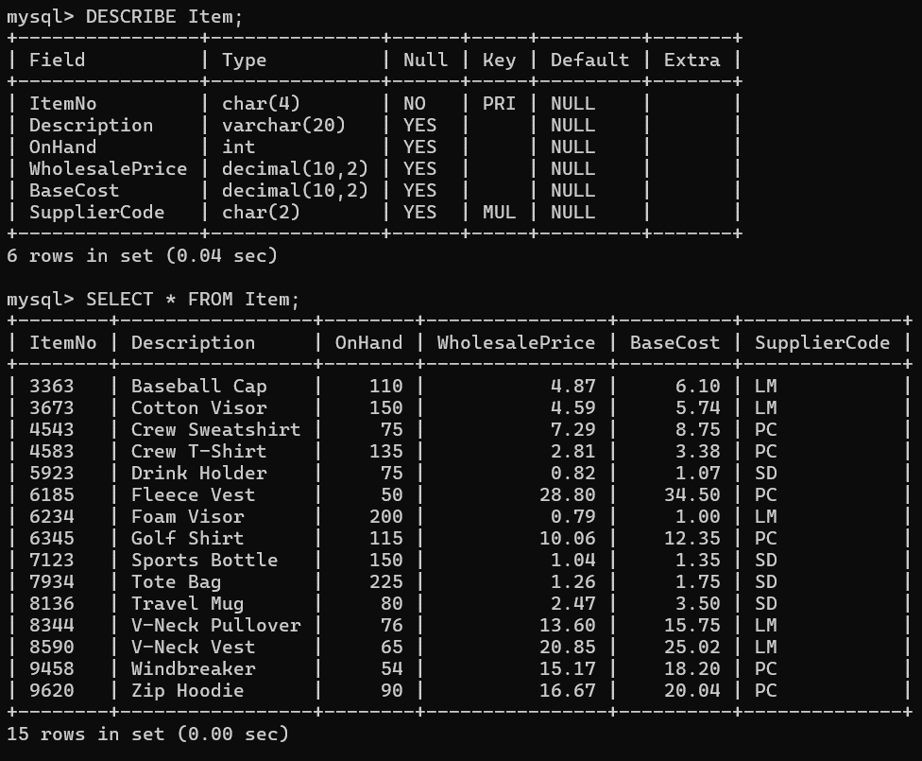

- Create a query for the Item table. Include the Item Number, Description, Wholesale Price, Base Cost, and Supplier Code. Save the query as Item Query.
Answer:

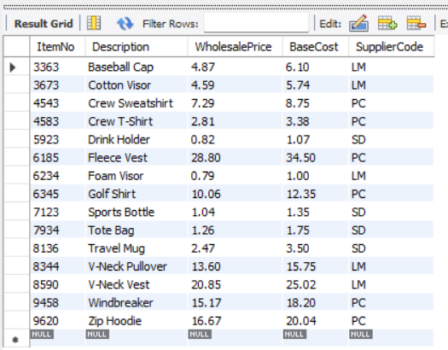

- Create a simple form for the Item table. Use the name Item Form for the form.
Answer:

- Drop the Supplier table.
Answer:

.

Structure of Supplier Table

FIELD NAME | DATA  TYPE | FIELD  SIZE | PRIMARY  KEY? | DESCRIPTION
Supplier Code | Short Text | 2 | Yes | Supplier Code (Primary Key)
Supplier Name | Short Text | 30 |  | Supplier Name
Telephone Number | Short Text | 12 |  | Supplier Telephone Number
Figure 1

Data for Supplier Table

Supplier Code | Supplier Name | Telephone Number
LM | Last Merchandisers | 803-555-7641
PC | Pratt Clothing | 517-555-3853
SD | Scryps Distributors | 610-555-8741
Figure 2

Structure of Item Table

FIELD NAME | DATA TYPE | FIELD  SIZE | PRIMARY  KEY? | DESCRIPTION
Item Number | Short Text | 4 | Yes | Item Number (Primary Key)
Description | Short Text | 20 |  | Description of Item
On Hand | Number |  |  | On-Hand Item
Wholesale Price | Currency |  |  | Wholesale Price (Caption)
Base Cost | Currency |  |  | Base Cost for Item
Supplier Code | Short Text | 2 |  | Supplier Code
Figure 3

Data for Item Table

Item Number | Description | On Hand | Wholesale Price | Base Cost | Supplier  Code
3363 | Baseball Cap | 110 | $4.87 | $6.10 | LM
3673 | Cotton Visor | 150 | $4.59 | $5.74 | LM
4543 | Crew Sweatshirt | 75 | $7.29 | $8.75 | PC
4583 | Crew T-Shirt | 135 | $2.81 | $3.38 | PC
5923 | Drink Holder | 75 | $0.82 | $1.07 | SD
6185 | Fleece Vest | 50 | $28.80 | $34.50 | PC
6234 | Foam Visor | 200 | $0.79 | $1.00 | LM
6345 | Golf Shirt | 115 | $10.06 | $12.35 | PC
7123 | Sports Bottle | 150 | $1.04 | $1.35 | SD
7934 | Tote Bag | 225 | $1.26 | $1.75 | SD
8136 | Travel Mug | 80 | $2.47 | $3.50 | SD
8344 | V-Neck Pullover | 76 | $13.60 | $15.75 | LM
8590 | V-Neck Vest | 65 | $20.85 | $25.02 | LM
9458 | Windbreaker | 54 | $15.17 | $18.20 | PC
9620 | Zip Hoodie | 90 | $16.67 | $20.04 | PC
Figure 4

